Missional Start Up Grant Form 2023-2024
Purpose- Start Up Grants to provide up to £5,000 for new initiatives or to enable significant developments in existing work
Process
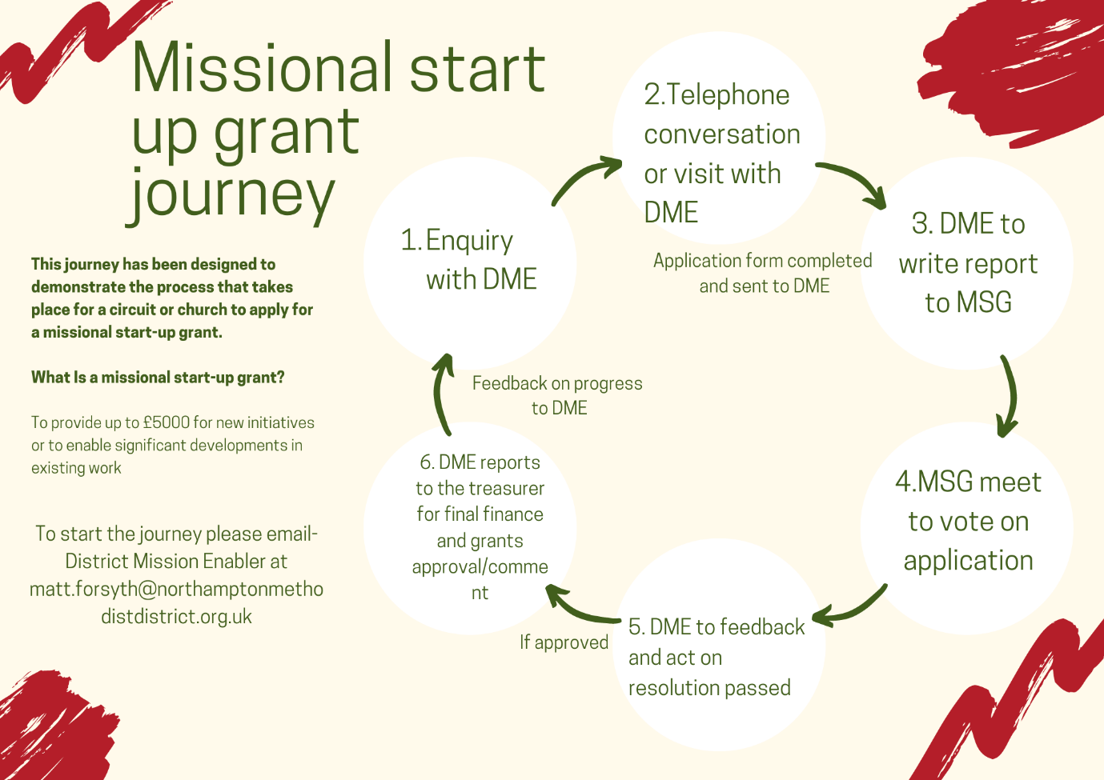
*The hope is that this process should take between 4-6 weeks

Missional Start up Grants form

Once complete, email your form to Matt Forsyth matt.forsyth@northamptonmethodistdistrict.org.uk

- What is your idea?

- Which new people will it reach?

- How will it work?

- How much money will you need?

- What will you spend the money on?

- Has the idea been agreed by your church council or circuit meeting if appropriate?

Contact Details
Name and position
Telephone Number
Email Address
Bank or CFB account details - for use if successful
Name of Bank:
Account Name:
Account No (do not use CFB account number 00260045.
Sort Code (not necessary for CFB payments):

