Justice, dignity & solidarity Report 2024/25

Status Summary – work in progress...
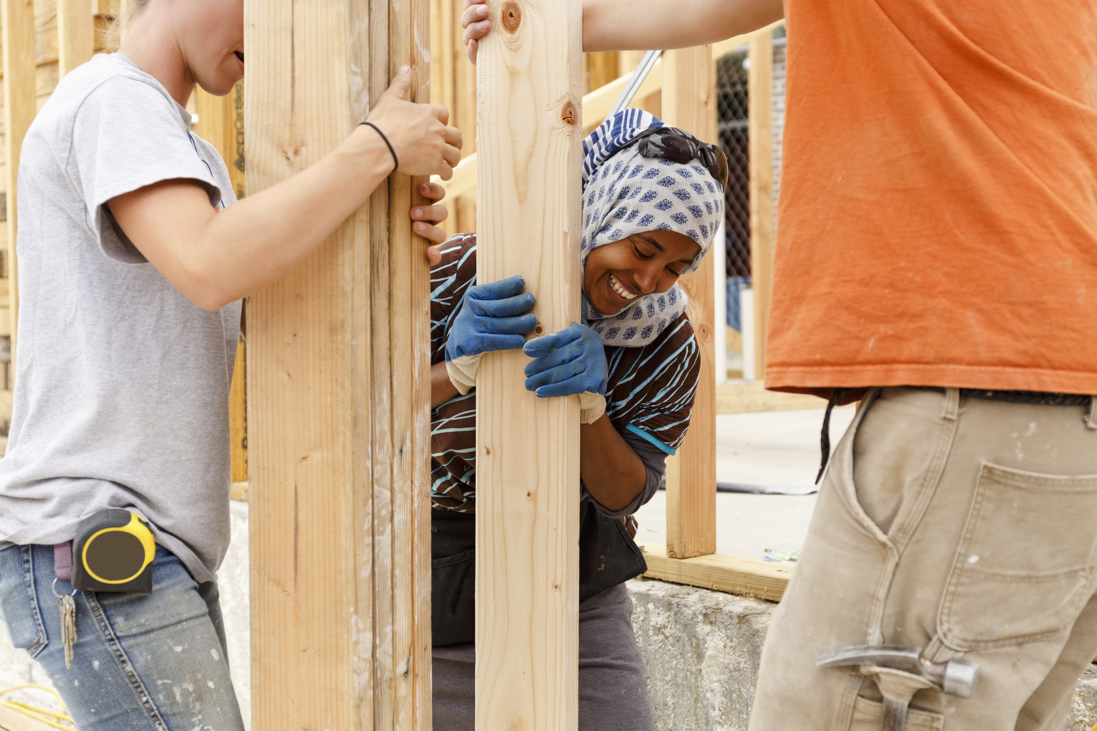

Project overview

The JDS Group tries to meet three - four times per year. We have been ably supported by Stuart Watkin from the Connexional Team. Since arriving in the District, I have taken over the chairing of the meetings to provide some stability as the membership evolves.

The JDS group supports the work of developing a culture, in this District, which is both justice-seeking and inclusive by:

raising awareness of inclusivity issues through a calendar of events

linking personal experience and faith into the JDS strategy.

communicating and sharing good practice

working jointly with others in the District

BUT we need your help in carrying out these tasks.

How?

can you join the group?

can you share good practice with the wider District?

Contact: Sonia Hicks via the District Office
Prepared by: Sonia Hicks (Chair – JDS Group)
April 2025

