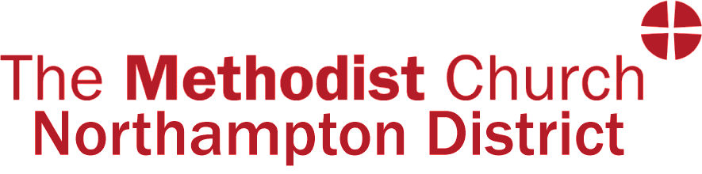

Guidance for churches seeking permission to cease to meet

This is provided for you to help you make a ‘summary’ of the information that the District Executive would need to know if a church felt that the time had come to ‘cease to meet’.

Before any submission to the District Executive, you must have consulted with the District Mission Enabler within the past 2 years. Contact- matt.forsyth@northamptonmethodistdistrict.org.uk

Once the DME has commented on your application form and returned it to you, please send it to the following:
Secretary of the District Executive lesleydinham@gmail.com
Chair of the District pa@northamptonmethodistdistrict.org.uk
Synod Secretary synod.secretary@northamptonmethodistdistrict.org.uk

Your application will be considered initially by the District Executive and then reported to the Synod for the final approval. You must inform the District Executive of the numbers present and their votes at both the Church Council and the Circuit Meeting.

Do, please, be aware that all of you dealing with these questions are in our prayers.

What is the present membership?

What is the number on the community roll?

What is the average adult attendance at worship, through the whole week?

What is the average attendance of under 18’s at worship or other events?

What other activities take place on the premises?

Provide a financial overview – e.g. income vs expenditure.

What provision will be made for the present congregation?

What impact will the closure have on the local community?

What other Churches and Sunday Schools/Young People’s Groups (Methodist and other ecumenical partners) are there in the neighbourhood and what are their distance from the property to be sold?

What initiatives have the membership tried, if any, to encourage the residents of the community to become part of the worshipping family?

Does the membership consider that their mission is complete from this building and why?

What are the plans for further Methodist presence, witness and mission in this context?

What arrangements have been made for on-going pastoral care in the community?

Have discussions taken place with other denominations in order to maintain a Christian presence in the locality and what was the outcome?

What options have you looked at for alternative use of the building? If sold, how will the proceeds of the sale be used to promote an effective presence in the community the Church once served?

Has the District Archivist been consulted regarding records and artefacts and records that might need to be conserved?

DME Comment:

