Trichy Link: Visit to Trichy (Tiruchirappalli – Thanjavur, Tamil Nadu, India)
21st January – 3rd February 2026: Reflections from Revd Andrew Farrington
For 14 days, a group of 8 people from Churches Together in Leicestershire visited the Churches of South India, Ecumenical Diocese of Trichy. The group comprised of seven (Lay) Anglicans and one Methodist (Presbyter) all of whom were received with the greatest respect and enthusiasm wherever they travelled in this vast province.
The group were based the simple accommodation at the diocesan managed Bishop Heber College, Trichy with the 13,000 students. The college sponsors a traveller settlement of street entertainers, recycles on-site wastepaper to form note pads for students, and rejoices in vibrant Christian witness and worship – 6.30 a.m. every day.
There is a rich, valued, and celebrated missionary heritage in the area, especially from Leicestershire. The college is placed within a large area of land incorporating a Mission Hospital, School for Girls, and the Diocesan office amidst the roaring traffic and perpetual busy-ness of the city centre famous renowned for its textile industry. No areas of wealth, just a sense of people working hard for basic needs.
The Methodist Mission Hospital was founded by one missionary with two beds and a commitment to care. It has grown to be the foremost hospital in the city offering free walk-in care to anyone in need. It relies completely on private donations for funding, with the senior paediatric surgeon doubling as lead manager in premises are that are moving through a major refurbishment. The large open chapel greets all who enter the premises. A place of care, healing, and prayer.
The Diocesan ‘Gospel Van’ became our second home. Journeying west to the boarders of Kerala, we encountered the E Lister girls orphanage, which leads (all on one site) to schooling, up to nurse training college, and employment at the hospital in Dharapuram. It was humbling to be joyfully greeted with cheering crowds who had prepared presentations, flower plantings, dances, and entertainments. We were able to reciprocate with songs, dances, and of course, prayer and words of encouragement. We moved to Udumalpet ready to encounter Sunday worship.
A fun-packed day with Revd Father David, minister of the town centre church of Immanuel. A brief list of events for one Sunday: 8.30 a.m. worship commences, church full to capacity with double the number sat outside (800+), assist with a baptism, attend the junior church (100+), pray individually with the long queue of people seeking healing, join the men’s fellowship, address a confirmation class (30+), prayer with those waiting on the street then at 12.30 p.m. head to the family home of the child who had been baptised for lunch. A service was held in the lounge with an impromptu invitation to preach, before a most magnificent lunch of local dishes served on a banana leaf. All the food was being cooked by one man in the backyard in enormous pans on open fires. No cutlery. Thankfully we had become skilled at eating everything literally by hand and all finger lickin’ good! No time to rest before offering prayers and blessing at funeral and then on to the burial.
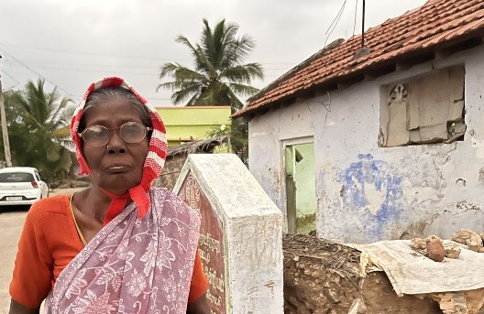
Late afternoon and evening were spent in a rural hamlet of single room dwellings where pastoral leaders moved house to house (singing and drumming as they went) to offer prayer and care. This has a very intense and deeply emotional time. Hearing stories of people just surviving. A common theme was the plight of widows who long for younger generations to find employment to bring income to sustain family life. The most challenging being an elderly couple who had no children or family and had now used all of their limited resource and livestock. ‘How can we continue to live?’ was their plea. Yet, there was a palpable sense of a caring community. The whole village gathered under the starlight by the simplest of chapels to sing and dance and ask for personal blessings and prayers. The Christmas decorations were still evident. A crude openair nativity scene seemed to offer the same vision of the fragility of that moment of incarnation and heavenly choirs set alongside the present living reality of the people who in worship were welcoming us.
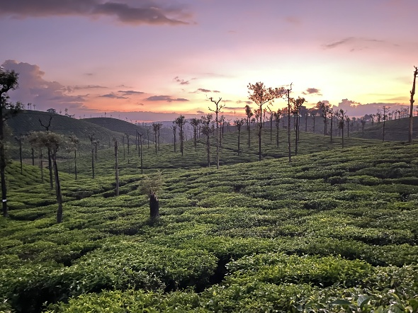
This vignette of one day was repeated throughout our stay: mountain top experiences (8000ft), jungle, tea-plantation, tourist destinations, national celebrations, youth rally, feeding of 4,000, rice fields, east coast, fishing villages, missionary landings and Christian church beginnings, a Roman Catholic pilgrimage church and shrine, tsunami devastation and recovery, places of deep faith and care. Wildlife everywhere – cows passing by in crowded streets, monkeys playing overhead, eagles circling, elephants strolling along, and Manse gardens that are nighttime playgrounds for cheetahs and tigers. And all was Christ-centred, challengingly peaceful, welcoming, and hopeful.
To experience India is to live with an assault of the senses. All things, in all places, and all the time. A perpetual motion or life joyful and stark, colour and darkness, light and shade, ease with nature, and everywhere environmental waste. This encounter is akin to the early church: growing congregations, confidence in evangelism in the face of some opposition, an outliving of care by the needy for the neediest. There is a need to build bigger churches to house growing congregations counted by families. Underpinning this, in Trichy at least, little talk of Anglican or Methodist – simply one Christian church community in each place. Peoples united by a common faith; grateful for their forbears whom they can trace back to Britain; and a desire to maintain the links to this area.
The Trichy Diocese provided for our every need. The group was welcomed generously; feed royally; served graciously, anointed frequently.
Rev’d Dr Sonia Hicks provided a pastoral letter of greeting and encouragement which was read and presented to the churches we visited. I feel truly blessed to have been given this life-changing opportunity which will have a most positive and lasting impact on my future ministry. I am willing to share my experiences within District and hope that the Trichy Link will continue to flourish.
Rev’d Andrew Farrington
Northampton Methodist District Ecumenical Officer (Leicestershire). 29th March 2026.

