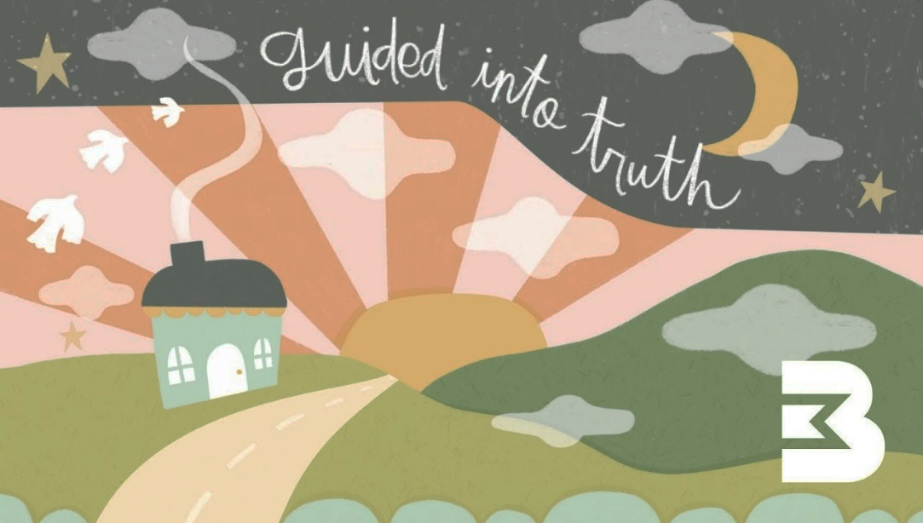

Welcome. We are a group of
Friends Exploring And Sharing Together, and over these four sessions we invite you to reflect, wonder, and get curious about life’s big questions using artwork and the ancient stories from the Gospel of John.

Come as you are—there is no preaching, no pressure. Just space for conversation and listening, and a chance to engage with the issues that matter most, using this rhythm:

Friends gather, both faces new and familiar.
Exploring works of art and words of scripture,
And making space for the questions that matter to you.
Sharing thoughts, wonderings, and discoveries, as
Together we listen and learn from each other's stories.

Whether you are spiritual, curious, or simply searching, your presence and your stories will be welcome at FEAST.

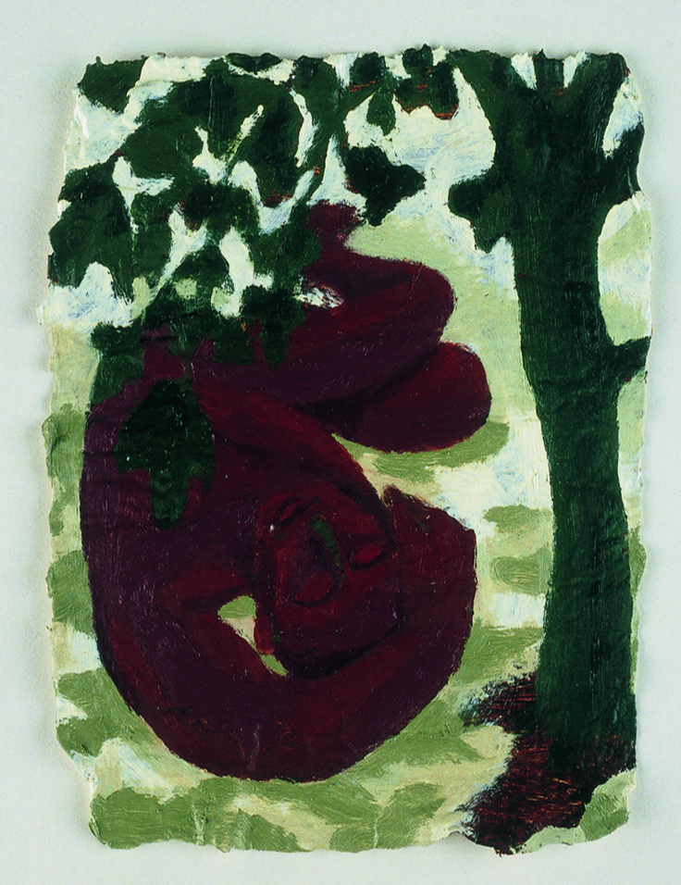
Session 1 – Guided into truth.

Mark Cazalet - Nathaniel (asleep under the fig tree) from the Methodist Modern Art Collection © TMCP, used with permission. www.methodist.org.uk/artcollection

🤝 Being Friends
- Have you ever experienced moments of unexpected hope? How did it shape your friendships with others?

- What does it mean to be a friend, an explorer, a sharer of faith?

🔍 Being Explorers
- What shapes, colours, or contrasts draw your attention? What do they reveal or conceal?

- Imagine this painting's actual size (18cm by 18cm – less than a handspan). Does this affect your initial reaction to it?

- How would you describe the figure on the ground?

✝️ And Respond ... Imagine being Nathaniel resting under the shade of the tree. How do you feel? What happens when Jesus walks past and sees you? Now read from John 1:43-51. What word, image, or emotion stays with you after hearing Jesus speak your name?

💬 Being Sharers:
- What does it feel like to be truly seen by someone—for who you are, not just what you do?

- Where do you see glimpses of Jesus' presence in your everyday life?

- What might it look like to invite others into something hopeful or life-giving in your own way?

🙏 Being Together

Our journey together is just the beginning; Jesus promises that those who follow him will witness even greater things. Faith in Christ is not an abstract idea; it becomes real through relationship and response.

Friends beloved by Christ, may we

Explore his call on our lives.

And being guided into truth, let us

Share his light, life and love as

Together we embrace God and all reality. Amen
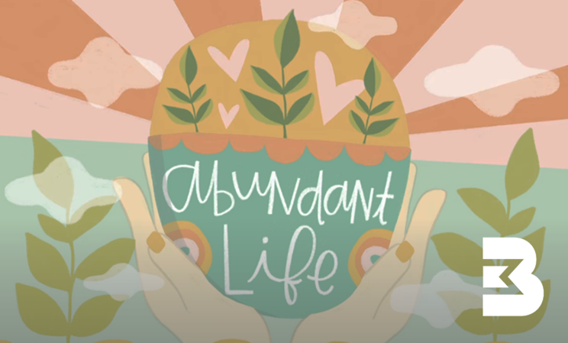

Welcome. We are a group of
Friends Exploring And Sharing Together, and over these four sessions we invite you to reflect, wonder, and get curious about life’s big questions using artwork and the ancient stories from the Gospel of John.

Come as you are—there is no preaching, no pressure. Just space for conversation and listening, and a chance to engage with the issues that matter most, using this rhythm:

Friends gather, both faces new and familiar.
Exploring works of art and words of scripture,
And making space for the questions that matter to you.
Sharing thoughts, wonderings, and discoveries, as
Together we listen and learn from each other's stories.

Whether you are spiritual, curious, or simply searching, your presence and your stories will be welcome at FEAST.

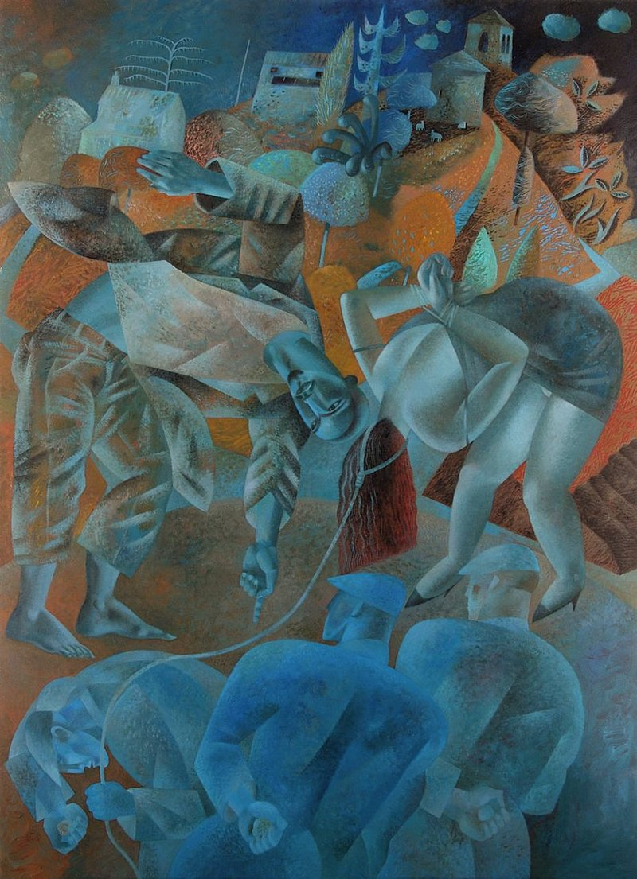
Session 2 – Abundant Life.
Clive Hicks-Jenkins – Christ Writes in the Dust – The Woman Taken in Adultery, 2011 from the Methodist Modern Art Collection © TMCP, used with permission. www.methodist.org.uk/artcollection

🤝 Being Friends
- Have you ever had a moment where someone defended you or stood by you when others did not?

- What does it mean to be a friend who offers safety instead of judgment?

🔍 Being Explorers
- Who do you notice first in this artwork—Jesus, the woman, the watchers?

- What emotions are being shown in the posture of the figures?

- What feelings or thoughts emerge as you think about how Jesus is portrayed?

✝️ And Respond ... Imagine being seen by Jesus—not for what others say about you, but for who you truly are. Now read from John 8:2–11. What word or words might Jesus be writing in the dust to stir your heart and head today?

💬 Being Sharers:
- Who are the people in your life, or community, who offer grace rather than judgement?

- What does it look like to offer someone a fresh start?

- Where do we see people today being pushed aside? What might your church or community do to step in like Jesus did?

🙏 Being Together

Jesus met this woman not with shame, but with compassion. He silenced the accusation against her, and opened the door to a new and abundant life through the restoration of her dignity, and mercy over judgement.

Friends, we are seen and known by Jesus, may we

Explore what it means to stand with love rather than judgement.

And being led into abundant life, let us

Share words and acts of mercy, courage and hope as

Together we walk with others toward a new life. Amen

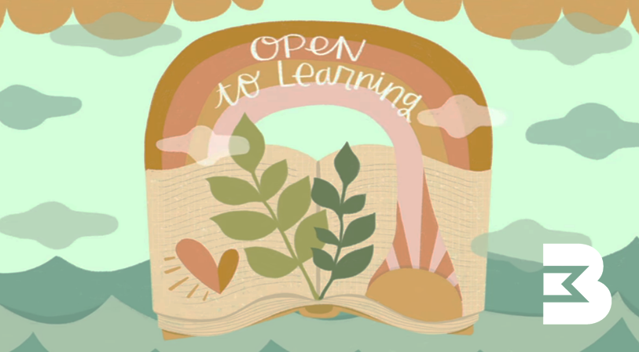
Welcome. We are a group of
Friends Exploring And Sharing Together, and over these four sessions we invite you to reflect, wonder, and get curious about life’s big questions using artwork and the ancient stories from the Gospel of John.

Come as you are—there is no preaching, no pressure. Just space for conversation and listening, and a chance to engage with the issues that matter most, using this rhythm:

Friends gather, both faces new and familiar.
Exploring works of art and words of scripture,
And making space for the questions that matter to you.
Sharing thoughts, wonderings, and discoveries, as
Together we listen and learn from each other's stories.

Whether you are spiritual, curious, or simply searching, your presence and your stories will be welcome at FEAST.

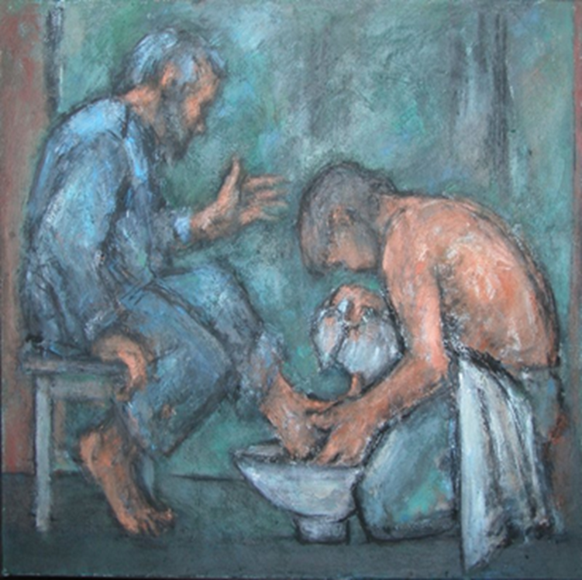
Session 3 – Open to Learning.

Ghrislaine Howard - The Washing of the Feet from the Methodist Modern Art Collection © TMCP, used with permission. www.methodist.org.uk/artcollection

🤝 Being Friends
- Have you ever had to let someone serve or help you when it felt uncomfortable?

- What can we learn about friendship from the vulnerability in this scene?

🔍 Being Explorers
- What stands out to you in this image—facial expressions, gestures, colour, or movement?

- Where do you place yourself within this painting—offering, receiving, or watching?

- What do you imagine the atmosphere is like in this moment—quiet, awkward, tender, challenging?

✝️ And Respond ... Imagine being in the room as Jesus kneels before you. You hesitate, unsure how to receive such love and humility. Now read from John 13:1-17. What shifts within you as you hear Jesus say “do as I have done to you...”?

💬 Being Sharers:
- How do you feel about humble service like this? What would be an equivalent act of humility for you today?

- Why might people (like Peter) struggle to receive love or care from someone they deeply respect?”?

- What helps you feel most comfortable when receiving love, help or support from others?

🙏 Being Together

It can be hard to accept humble service, especially when it is offered by someone we really respect. And it can be just as hard to be humble towards others. But humility, along with mercy and compassion, is at the heart of Jesus’s teachings.

Friends, as we kneel with open hands and hearts, may we

Explore the example Jesus sets before us.

And being open to his learning, let us

Share in acts of loving service with humility and courage as

Together we grow in grace and walk in his way. Amen

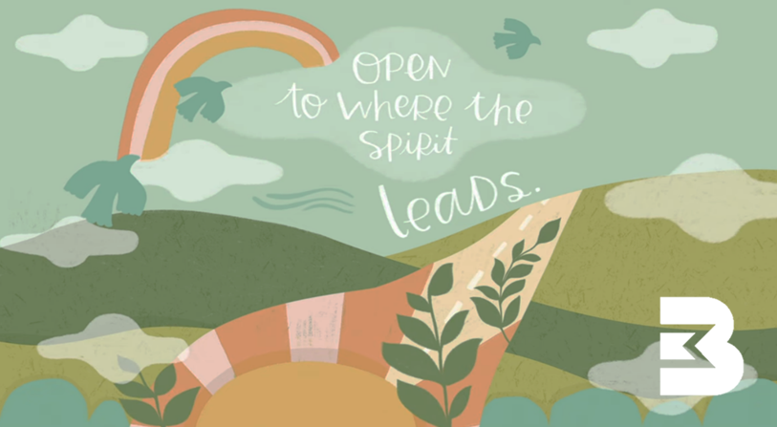

Welcome. We are a group of
Friends Exploring And Sharing Together, and over these four sessions we invite you to reflect, wonder, and get curious about life’s big questions using artwork and the ancient stories from the Gospel of John.

Come as you are—there is no preaching, no pressure. Just space for conversation and listening, and a chance to engage with the issues that matter most, using this rhythm:

Friends gather, both faces new and familiar.
Exploring works of art and words of scripture,
And making space for the questions that matter to you.
Sharing thoughts, wonderings, and discoveries, as
Together we listen and learn from each other's stories.

Whether you are spiritual, curious, or simply searching, your presence and your stories will be welcome at FEAST.

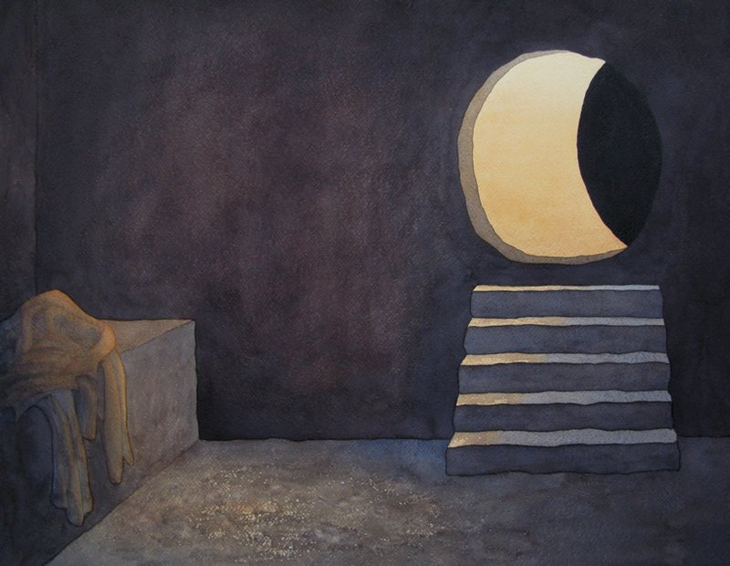
Session 4 – Open to where the Spirit leads.
Richard Bavin – The Empty Tomb from the Methodist Modern Art Collection © TMCP, used with permission. www.methodist.org.uk/artcollection

🤝 Being Friends
- Have you ever looked for hope or meaning, only to find it in a place—or person—you didn’t expect?

- How does friendship shape the way we recognize Jesus in our lives?

🔍 Being Explorers
- What do you notice as you look at the light, shapes, and atmosphere portrayed in this image?

- How is the active presence of God expressed in this work?

- What emotions arise as you sit in the silence of what has just taken place?

✝️ And Respond ... Imagine standing outside the empty tomb. You have been searching for Jesus, but he is not where you expected. Now read from John 20:1-18. What stirs in your heart and head as you hear Jesus call your name, as he did with Mary?

💬 Being Sharers:
- How does Mary’s response, “I have seen the Lord,” challenge or inspire you?

- How does telling your story—or hearing someone else’s—shape your understanding of Jesus?

- How might the empty tomb expand your imagination for what’s possible—in faith and in life?

🙏 Being Together

In a context where women’s voices were often marginalised, it is Mary who first witnesses the risen Christ. She is sent to share the good news. Like her, we are called to be resurrection people—courageous in uncertainty, open to transformation, and ready to share stories of transformation.

Friends, Jesus calls us each by name, may we

Explore his living presence in our world.

And being open to where the Spirit leads, let us

Share words of Good News with courage and hope as

Together we bear witness to his resurrection power. Amen

