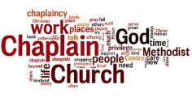
The Overstone Project
November marked our 3rd year in the new estates in Overstone, we continue to find ways to live out our vision of building friendships and helping to build the new community in Overstone; sharing God’s love and light, with a hope that we can build a tangible expression of faith. Here is a brief overview of what we have been doing over the summer and autumn months.
July – December 2023
Summer Activities: Throughout the summer (when there was no rain), we created a space on the two estates for young families to gather and play. This is the second year that we have done this on the new estate in The Avenue, and the Overstone Gate estate have experienced this for the first year. From Tuesday to Thursday in the afternoons, we set up outdoor games and craft activities for families to enjoy. The feedback we received confirms that the summer activities helped to build community cohesion, as it gave children and parents a space where they could spend time together.
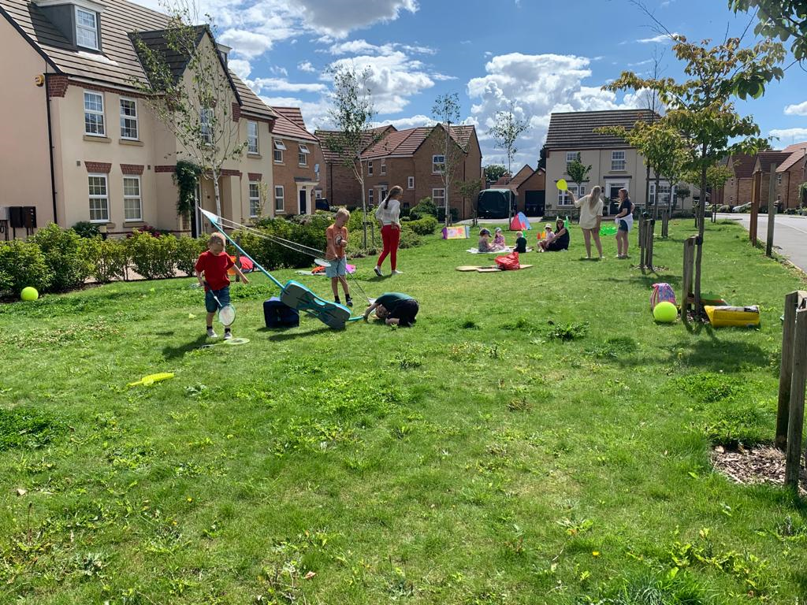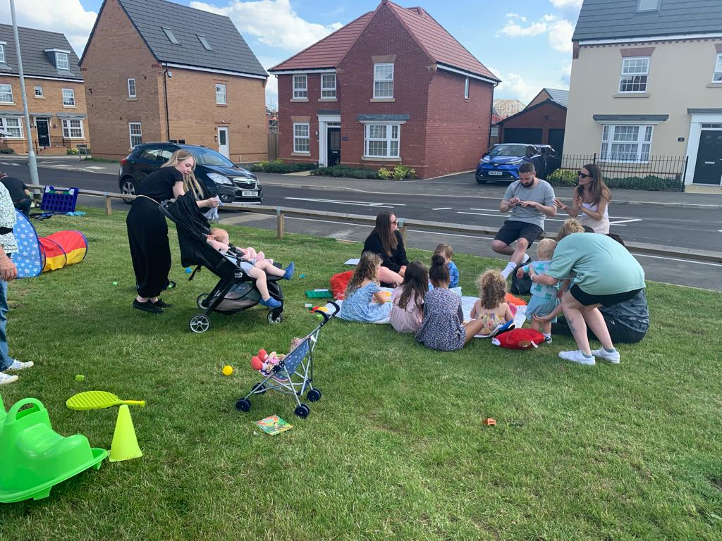
Some of the feedback: “I pass my neighbours all the time and just say ‘Hi’, we’ve never stopped and chatted before – thank you!” “I haven’t seen anything happen on here before, it’s so great to see the space being used.” “Thank you so much!”
Family Funday: Our Family Fun Day in September was a wonderful community event. We invited a Face Painter to come along; we had outdoor activities and crafts; Biscuit decorating and prizes for winning Hook the Duck! Again, it was an opportunity to build community, build relationships and be a Christian presence in the community. I am often asked why we are doing what we are doing; and I have often refused financial contributions as parents are surprised that we are not charging them for the activities. My answer is always the same, “The Methodist Church wants to be a blessing in your community.” I believe we are accomplishing that.

Christmas Activities: Both estates will be having a Christmas carol event. I was overjoyed to be contacted by a resident who moved to the estate this April, and he wanted to know if we could help him to put on an event. This was music to my ears! So, we are supporting a Christmas event in Overstone Gate and leading one in The Avenue. We are planning to share the Christmas Story, sing carols, take part in outdoor activities and drink mulled wine. The Aldi Store have faithfully agreed to donate mince pies to the event. Christmas will provide another opportunity to bring the community together, to share the message of Christ’s birth and to pray with the community.

The Walking Group: Continues to be a staple part of our activities, meeting two Saturdays per month to roam the paths near and further afield. We have been walking together since the start of the year and after many miles and numerous conversations, we have found very strong bonds. I have wrestled with approaches of how to share faith and to be more intentional in creating conversations around faith. So far, I have found that my best approach is to share my personal life stories and describe how my relationship with God has impacted my life. I will continue to think, listen to others and decern other approaches to this, as the relationships created continues to offer and welcome opportunities to share faith.
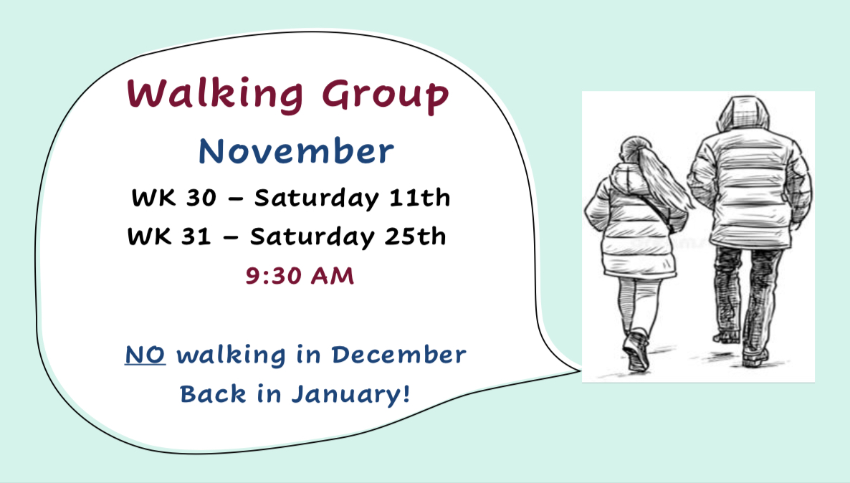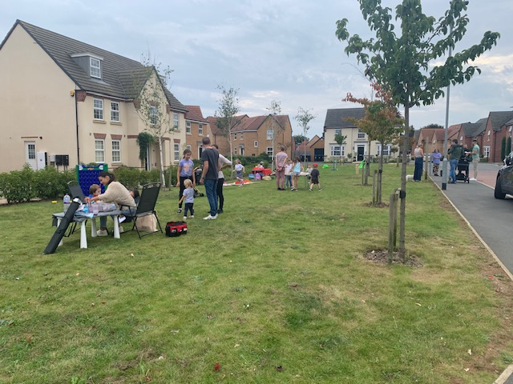
Overstone House Care Home: Monthly services continue to be a blessing, working with Revd Katrina (Church of England), we offer ongoing support and friendship to the Home. The Steering Group (I’ll just take a moment to say how AMAZING the Steering Group is!) thought it would be wonderful if we gave Christmas presents to both staff and residents (58 people). Jointly with the Church of England we have purchased presents for each member of staff and each resident, these will be presented to them when we hold the Christmas service. We will also use their Christmas cards as an opportunity to write a prayer for each staff member.

Welcoming new residents: After a pause in the summer, welcoming new residents has resumed. This involves a doorstep visit with a gift bag containing goodies and information about our presence in Overstone. The Hello Bag has been an invaluable tool as it gives me a viable reason to knock on a door, introduce myself and have a conversation if invited to do so.

Pastoral Care: On several occasions I have been invited to residents’ homes, or invited to meet somewhere for a chat. On these occasions it is clear that people are feeling isolated and in need of an ear. Prayer has also been welcomed on these visits, which has brought so much joy to my heart. The community are aware that we are there and that support and encouragement is available if and when it is needed.
Moving Forward
- I have been in contact with the new Boy’s School which is due to open next year. The Head has agreed to meet with me for a conversation about my involvement with the community and a discussion about possible engagement with new school. Hopefully this should take place before the end of this year.

- Our continuous prayer is that opportunities for discipleship will arise. We haven’t yet seen an opportunity to start a Small Group, but we hope that such conversations could talk place in the coming year.
Please keep these as points of prayer. Thank you!
Mel Brown - Overstone Pioneer Community Chaplain

