Sabbatical report – Ruth Charlesworth

I set myself up with a hefty reading list, looking at creativity and spirituality and ways of using beads in prayer. It was a joy simply to be able to read, and alongside this I spent some time revisiting childrens stories and discovering new ones. Many of them will make an appearance in worship or fellowship gatherings as time goes on. I also undertook a couple of short retreats which enabled me to have a dable in painting – although I’m told that my style is not that of my chosen medium as I enjoyed working with watercolours and my guide thought I should perhaps have chosen acrylics or oils! The big piece of work though was something that began as a bit of a throw away line, that I might just make a quilt of prayer, was something that grew on me as time went on, and what has resulted is a quilt that began with prayer, has many stories and reflections to it, and took on a life of its own. Being mainly hand stitched, pieces travelled with me as I spent time away from the manse and all finally came together in a way that has enabled stories to be told and shared, and hopefully will continue in this way.

There are several panels and the journey began with a dreamcatcher which is a cross stitch (9,600 in all!) which was sparked by the words in Joel 2 of dreams and visions. It was both about personal prayer within my own journey, and prayers for the Circuit of which I am a part as we venture into the future. The prayers focused on discerning what God was asking of me, and what the future shape of the Circuit might look like in the likely need for change. I was also conscious of the divides still in some places, partly over the God in love unites and where this relatively new Circuit is still knitting together. There are two half rainbows with a boy and a girl blowing bubbles, and which remain as two pieces on the quilt even though they could have been sewn together. They are left seperately to remind us that the divides are often what we put there ourselves, but that coming together in one is where we are in God’s sight. I watched the Fisherman’s Friends films, and found myself drawn in to the words of a song which talks about difference and all being part of one family which then began the wider reflection and prayer on a broken world. The rainbow also being symbolic of the NHS during COVID was a guide to pray for all those working in the care of others, not just in hospitals, but in care homes and indeed in the homes of people. There are crosses patched together which began as prayers for those who were suffering in some way, not just health but with circumstances and I reflected on the story of the hill of crosses which is regularly dismantled, but still the people climb the hill and replace them. There are fish and shells, both symbols of early Christianity and opportunities to pray for the Church throughout the world – the church that meets in freedom, and the church that meets behind locked doors because of persecution and oppression. There is a stained glass cross which also has butterflies stitched as if they have landed on it. This is in part about the beauty of all the different bits of glass that reflect light around many of our buildings. In the post Easter time it was also about the journey of resurrection and new life symbolised by the butterflies and a native American story which told of the butterflies on the cross of Jesus as he was crucified.

Two panels of sheep reflect different streams of prayer. One was about the space and time which reflected on Psalm 23, and alongside that a contemporary version which speaks of the Lord is my pace setter, I shall not rush. This was about prayer for those who were set aside from their regular life and routines in order to be renewed, through holidays and restful times. I then began to focus on the lost sheep that Jesus seeks out and the prayers were focussed on the many people we might describe as ‘lost’ – not just in a faith setting, but those for whom life has just become too difficult or confusing. Onward again the reflections turned to the conversation between Jesus and Peter, where Peter is told to ‘feed my sheep’. This was about prayer for all in leadership, for their resourcing, strengthening and renewing. Then came the doves and the prayer for the Holy Spirit to come in power and a reflection on Acts 2 and the words of the banner that appear on the drive of Cliff College for their gatherings – ‘You will receive power when the Holy Spirit comes upon you’, and on the reverse the question ‘Did you receive power?’.

There are two woven panels, one of ribbons which contain the names of people with whom I have regular contact in the churches and beyond. They are all woven together in a variety of colours as we are woven together as part of the body of Christ. The other is an eternal plait – two circles of fabric cut and woven together to make a circle. The reflecting began with the Covenant promise we make each year, and the two pieces of fabric similar in colour and pattern so it is not immediately obvious where one starts and another begins. The pieces are not all stitched together and you can feel where the weaving is. Further reflections focussed on ‘In search of a round table’ as I reflected on the worlds of the promise again and the way that God weaves us together, along with a poem by Raymond Foss which talks about us all being woven into a beautiful fabric so that Christ may be seen among us

There is a small panel with praying hands, and alongside it a panel with buttons, curtain rings and other things that can be felt. Initially it was praying for those with dimensia and altzheimers, and was based on the idea of a twiddle muff which gives the person something to occupy their hands. It deepened then into prayers for those whose sight is compromised, those who feel they are living in the dark and using touch and other senses to help. There is a robin with a missing piece filled with upside down poppies and with one or two dragonflies. This was about prayinng for those who are grieving , some because of loss of loved ones, others with loss of job or home, and a variety of other needs. There is something about the hole that is left behind which is full of memories, but everything feels like it’s upside down and the dragonflies were added after reflecting on the story of the dragonfly which is often used with children going through the loss of significant people. The missing jigsaw piece appear s on another panel of poppies which was about looking for the bigger picture, and not being held back by memories. There is also a small panel of flowers on stones which came from a reflection on the white stones holding our names in Revelation along with the stones crying out, and what would they say from the gospels. The flowers represent the beauty growing in desolate places along with that sense of belonging and wanting to share the stories.

Finally a bit of fun – the peom When I am an old woman I shall wear purple! This was about the rules and expectations of society and communities on everyone, some of whom can conform and some who can’t, and many prayers under many different headings! It is also a little bit of the ‘me’ I rediscovered in this journey….

Having come near to completing the quilt I found a story entitled My Quilt, which speaks of people standing before God with a pile of squares being sewed together to represent their lives. As each quilt is sewn there are beautiful results, and the person writing is worrying because their squares are tatty, threadbare and full of holes. As they are sewn together it still looks rather poor compared to the others, but when it is finished and held up to the light there is a gasp as everyone realises that the light is shining through all the untidy and imperfect bits where there are holes and tears, and the result is that the face of Jesus is shining through – and my prayer that in some small way as this is shared with others, the face of Jesus might shine through.

The back of the quilt simply holds a word map which again contains many prayers for the world in which we live and is very deliberately set within fabric which is covered with moons and stars as I reflected on the Paul Field song – God of the moon and stars, the God of all, whoever and wherever we are. I also decided I wasn’t finished there and began to create some pocket quilts using up some of the left over fabric, and have been giving them away with a little prayer card, some of which have also been taken and sent to people I’ve never met. Perhaps that’s another little way of drawing people close to God!

Quilt front (upside down!)

Panels of prayers that also became stories….

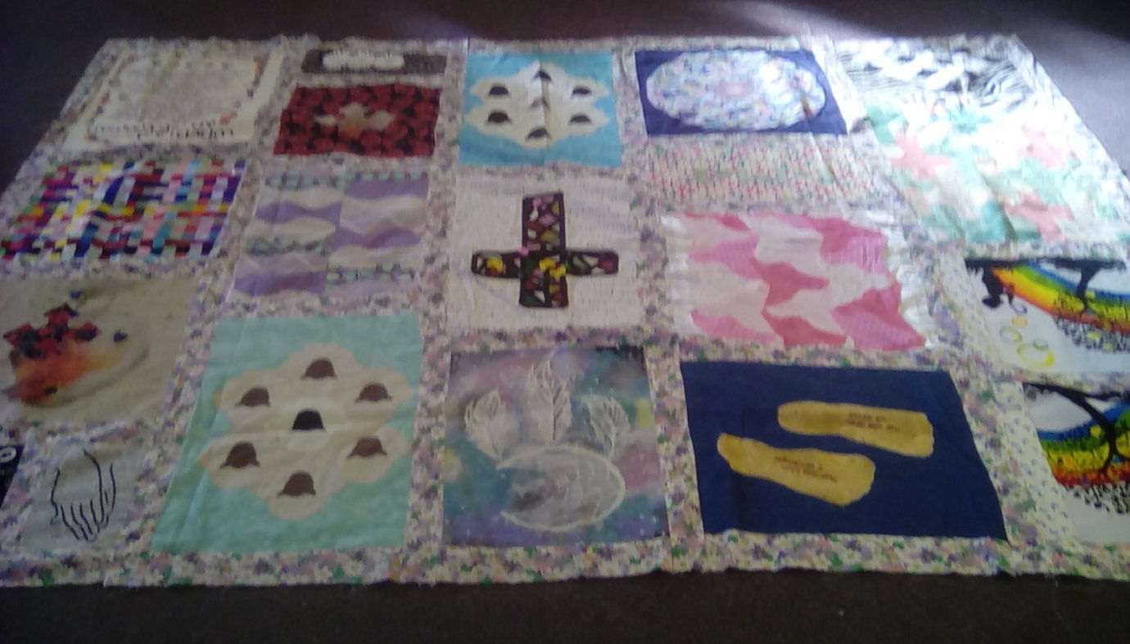

Back – a map of the world and prayers for the variety of world situations appearing on the news and in the newspapers.

